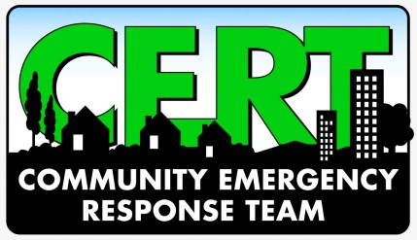
*REGISTRATION*

Applicants Name: ___________________________
Applicants Phone: _______________ Email Address: _______________________
*ALL Applicants need to submit this form or information to Sebastian County Dept. of* *Emergency Management and Public Safety*
Email Info to : dem@co.sebastian.ar.us
CLASS SCHEDULE

TUESDAY 02-21-17 6PM-9PM
WELCOME- REGISTRATION AND INTRODUCTIONS
SESSION 1 INTRODUCTION TO CERT AND DISASTER
PREPAREDNESS
SESSION 2 INCIDENT COMMAND AND CERT ORGANIZATION
THURSDAY 02-23-17 6M-9PM
SESSION 3 SMALL FIRE SUPPRESSION
SATURDAY 02-25-17 8AM-4PM
SESSION 4 DISASTER MEDICAL OPERATIONS PART 1
SESSION 5 DISASTER MEDICAL OPERATIONS PART 2

TUESDAY 02-28-17 6PM-9PM
SESSION 6 LIGHT SEARCH AND RESCUE
SESSION 7 DISASTER PSYCHOLOGY

THURSDAY 03-02-17 6PM-9PM
SESSION 8 TERRORISM AND CERT

SATURDAY 03-04-17 9AM-1PM

FINAL EXERCISE AND CERTIFICATION PACKETS

